Deep Learning

Lab 3

Name: Yadukrishnan

Reg No: 21BAI1210

Slot: L55 + L56

[Github link](https://github.com/yadu-tv/deep-learning-lab) to all the below codes

Software used:

Tensorflow, Python, Scikit-learn, Pandas, Numpy

* Question 1

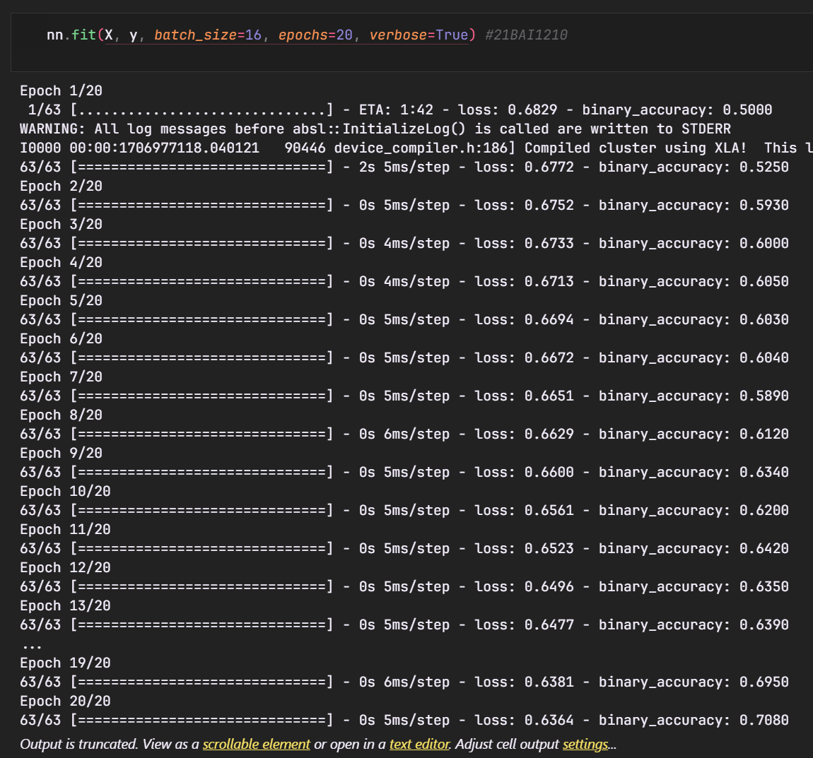

* Question 2 and 3

